Atitit 实用的chrome插件 attilax总结

目录

1. 扩展类 1

1.1. 油猴脚本 1

2. Sns 资料类与im类 1

2.1. Blue Messenger 1

3. Google系列 2

3.1. Calenda doc driver插件 2

4. 翻墙类 2

4.1. 2. 广告的天敌:Adblock Plus 3

# 扩展类

## 油猴脚本Tampermonkey

# Sns 资料类与im类

## Pushbullent

## Telegram

## Blue Messenger

概述  与您的设备兼容 Facebook, Facebook Messenger, Facebook Lite. Ad Block. Feed, notifications, photo zoom, download, messages, Web Chat for Chrome. ★★★★★ Access directly to all Facebook™ platforms just like you where in your smartphone 📱 That means that Facebook™, Facebook Messenger™ 💬 and Facebook Lite™ are available through this App. Very Low CPU/RAM/Bandwidth consumption 📌 An easy-to-use and lite app for Facebook and Messenger 😇 Blue Messenger is the easiest way to open and use Messenger from your desktop machine (PC, MAC or Linux) 📺 Clicking on the toolbar button, renders Facebook and Messenger in a standalone UI. The window is re-sizable to your desired choice and all the changes are auto saved to the memory 🔩 Note, you need to have a Facebook account 🏅 Blue Messenger is a lite Addon and does not add any additional burden to your browser 🎯 The popup has a built-in "Always-On-Top" and Sidebar that enables you to do multi-tasking 🦇 <https://chrome.google.com/webstore/detail/blue-messenger/ecmfchgfmbbddembehpkopmhjiepcckd>

# Google系列

## Calenda doc driver插件

# 翻墙类

**三. 各类插件**  
**1. 谷歌搜索助手** *[http://www.cnplugins.com/](https://link.zhihu.com/?target=http://www.cnplugins.com/" \t "https://zhuanlan.zhihu.com/p/_blank)*(这是谷歌插件网,你需要进去搜索 谷歌搜索助手 ,按照提示下载即可)  
由于今天分享的插件都是在谷歌应用商店下载的正版插件,对于很多不能翻网的小伙伴很不友好,所以我们首先需要安装的第一个插件就是谷歌搜索助手,它可以帮你访问海外的网站,下载和浏览都不是问题,至于插件安装方式,该插件需要下载好后,需要将后缀名改为 rar 然后解压 在扩展程序页面点击加载已解压的扩展程序,选择即可(这操作比起其他插件略显麻烦,但是功能也是很强大的)

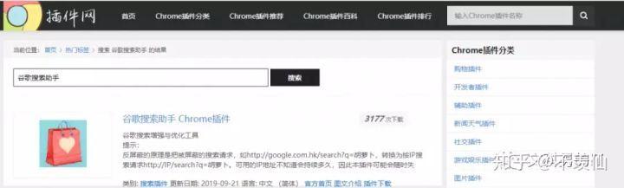

**安装好谷歌访问助手后,剩下的插件就可以直接搜索网址添加了**

## 2. 广告的天敌:Adblock Plus

## Google翻译插件

**放大镜:imagus**

## **多站点以图搜图：[Search By Image](https://link.zhihu.com/?target=https://greasyfork.org/en/scripts/2998-search-by-image" \t "https://zhuanlan.zhihu.com/p/_blank)**

## **小说阅读模式**

## ****注释&录屏 —— Awesome screenshot****

**一键管理扩展 —— Extension Manager**

# 油猴脚本扩展

## **一键切换不同的搜索引擎：[搜索引擎一键切换 soTab](https://link.zhihu.com/?target=https://greasyfork.org/zh-CN/scripts/14856-sotab-search-engine-switcher" \t "https://zhuanlan.zhihu.com/p/_blank) 油猴脚本**

## **解除网页禁止选择文本：[网页限制解除(改)](https://link.zhihu.com/?target=https://greasyfork.org/zh-CN/scripts/28497-remove-web-limits" \t "https://zhuanlan.zhihu.com/p/_blank)**